**Chapter 3 – Infrastructure Optimization**

**Epic Game Store**

**CDOF3 - LE QUERNEC Loévan / MARTIN Santiago / RINGEISSEN Léo / SALEH Julien**

Table of Contents

MongoDB Queries 2

Sharding Key Selection 13

Cost Calculation – Network Cost Model 14

Conclusion 14

# MongoDB Queries

## View reviews for a specific game

db.games.aggregate([

  {

    $match: { game_slug: "celeste" }

  },

  {

    $lookup: {

      from: "open_critic",

      localField: "id",

      foreignField: "game_id",

      as: "reviews"

    }

  },

  {

    $project: {

      name: 1,

      "reviews.author": 1,

      "reviews.rating": 1,

      "reviews.comment": 1,

      "reviews.date": 1

    }

  }

])

We have here maybe between 20 and 30 critics, average for an independent game.

## Find hardware requirements for a game

db.games.aggregate([

  {

    $match: { game_slug: "celeste" }

  },

  {

    $lookup: {

      from: "necessary_hardware",

      localField: "id",

      foreignField: "fk_game_id",

      as: "necessaryHardware"

    }

  },

  {

    $project: {

      name: 1,

      "necessaryHardware.operating_system": 1,

      "necessaryHardware.processor": 1,

      "necessaryHardware.memory": 1,

      "necessaryHardware.graphics": 1,

      "necessaryHardware.graphics_memory": 1

    }

  }

])

In this request, we have two results, because we have the minimum and the recommended hardware for each game. Here, for Celeste, because it does not require a huge configuration, minimum = recommended hardware.

## Search for social networks for a game

db.games.aggregate([

  {

    $match: { game_slug: "rainbow-six-siege" }

  },

  {

    $lookup: {

      from: "social_networks",

      localField: "id",

      foreignField: "fk_game_id",

      as: "socialNetworks"

    }

  },

  {

    $project: {

      name: 1,

      "socialNetworks.url": 1,

      "socialNetworks.description": 1

    }

  }

])

Rainbow Six Siege has a few links to different social networks.

## View tweets related to a game

db.games.aggregate([

  {

    $match: { game_slug: "shadow-complex" }

  },

  {

    $lookup: {

      from: "twitter_accounts",

      localField: "id",

      foreignField: "fk_game_id",

      as: "twitterAccounts"

    }

  },

  {

    $unwind: "$twitterAccounts"

  },

  {

    $lookup: {

      from: "tweets",

      localField: "twitterAccounts.id",

      foreignField: "twitter_account_id",

      as: "tweets"

    }

  },

  {

    $unwind: "$tweets"

  },

  {

    $project: {

      name: 1,

      "twitterAccounts.username": 1,

      "tweets.text": 1,

      "tweets.quantity_likes": 1,

      "tweets.timestamp": 1

    }

  }

]);

Here, we searched the tweets related to the game ‘shadow-complex’ and we found some amout of tweets related to it. The amount of tweets related is different for each game, it’s a independent game here, so not a huge amount.

## Average rating for each game over time

db.games.aggregate([

  {

    $lookup: {

      from: "open_critic",

      localField: "id",

      foreignField: "game_id",

      as: "reviews"

    }

  },

  {

    $unwind: "$reviews"

  },

  {

    $addFields: {

      "reviews.date": { $toDate: "$reviews.date" }

    }

  },

  {

    $group: {

      _id: { name: "$name", month: { $month: "$reviews.date" } },

      avgRating: { $avg: "$reviews.rating" },

      reviewCount: { $sum: 1 }

    }

  },

  {

    $project: {

      name: "$_id.name",

      month: "$_id.month",

      avgRating: 1,

      reviewCount: 1

    }

  }

])

## Identify most active games on twitter

db.games.aggregate([

  {

    $lookup: {

      from: "twitter_accounts",

      localField: "id",

      foreignField: "fk_game_id",

      as: "twitterAccounts"

    }

  },

  {

    $unwind: "$twitterAccounts"

  },

  {

    $lookup: {

      from: "tweets",

      localField: "twitterAccounts.id",

      foreignField: "twitter_account_id",

      as: "tweets"

    }

  },

  {

    $unwind: "$tweets"

  },

  {

    $group: {

      _id: "$name",

      tweetCount: { $sum: 1 }

    }

  },

  {

    $sort: { tweetCount: -1 }

  }

]);

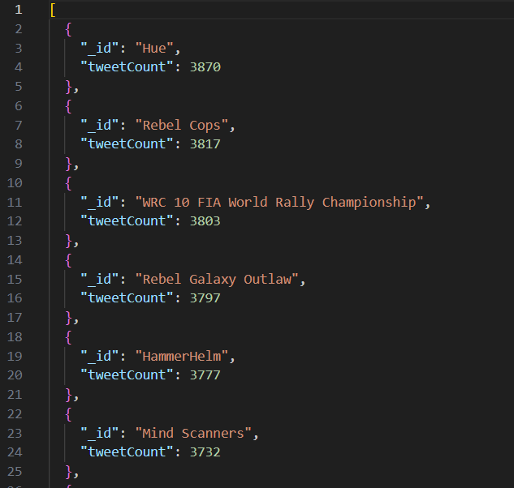

Now we have a tweets count for each game. This query takes a huge time compared to the other queries, because the collection *tweets* has a lot of data.

## Top 5 publishers by average game rating

db.games.aggregate([

  {

    $lookup: {

      from: "open_critic",

      localField: "id",

      foreignField: "game_id",

      as: "reviews"

    }

  },

  {

    $unwind: "$reviews"

  },

  {

    $group: {

      _id: "$publisher",

      avgRating: { $avg: "$reviews.rating" },

      reviewCount: { $count: {} }

    }

  },

  {

    $match: { reviewCount: { $gte: 10 } }

  },

  {

    $sort: { avgRating: -1 }

  },

  {

    $limit: 5

  }

])

## Trending genres based on twitter activity and reviews

db.twitter_accounts.aggregate([

  // we join the tweets with the twitter accounts

  {

    $lookup: {

      from: "tweets",

      localField: "id",

      foreignField: "twitter_account_id",

      as: "tweets"

    }

  },

  // we add a field to count the number of tweets for each account

  {

    $addFields: {

      tweetCount: { $size: "$tweets" }

    }

  },

  // we join the twitter accounts with the games

  {

    $lookup: {

      from: "games",

      localField: "fk_game_id",

      foreignField: "id",

      as: "games"

    }

  },

  {

    $unwind: "$games"

  },

  {

    $unwind: "$games.genres"

  },

  // we regroup the games by genre

  {

    $group: {

      _id: "$games.genres",

      totalTweetCount: { $sum: "$tweetCount" }

    }

  },

  // we sort the genres by the total number of tweets

  { $sort: { totalTweetCount: -1 } }

])

Here, the most difficult query we had to do. It’s different because we aggregate from the *twitter_accounts* collection to join on the *games* and *tweets* collections. We implemented a counter to finally count the tweets for each genre.

# Sharding Key Selection

## Strategy 1 : ShardinG BY GAME SLUg

**Optimized for user queries : Shard by game_slug (hashed) and ensure secondary indexing on publisher to handle analytics queries.**

Advantages:

* The relatively small size of the games collection ensures efficient lookup when combined with the game_slug key.
* Joins with tweets, open_critic, or other collections remain efficient because the majority of queries start with a filter on game_slug.

Challenges:

* The large size of the tweets.csv file introduces potential shard imbalance if some games generate significantly more tweets than others (e.g., trending games).

## Strategy 2 : ShardinG BY publisher

**Optimized for analytics : Shard by publisher (hashed), ensuring efficient aggregation and secondary indexes on game_slug for user lookups.**

Advantages:

* Distributes the large tweets and open_critic data across publishers.
* Ideal for queries aggregating data by publisher or across genres, as this avoids scatter-gather across shards.

Challenges:

* Scatter-gather queries will be frequent for user-facing queries filtering by game_slug.

# Cost Calculation – Network Cost Model

Here is our cost model:

|  |  |  |  |  |
| --- | --- | --- | --- | --- |
| Query | Database Schema 1 | | Database Schema 2 | |
| Sharding 1 Cost | Sharding 2 Cost | Sharding 1 Cost | Sharding 2 Cost |
| R𝑢1 | 10 | 30 | 50 | 80 |
| R𝑢2 | 10 | 25 | 40 | 70 |
| R𝑢3 | 10 | 20 | 50 | 80 |
| R𝑢4 | 30 | 50 | 70 | 100 |
| R𝑑𝑎1 | 60 | 100 | 40 | 70 |
| R𝑑𝑎2 | 70 | 120 | 50 | 80 |
| R𝑑𝑎3 | 90 | 150 | 70 | 110 |
| R𝑑𝑎4 | 100 | 180 | 80 | 140 |
| Weighted Total | 123580 | 349860 | 576110 | 926880 |

# Conclusion

Here are the many observations we can make from the board we got in the previous section.

Schema 1's Overall Efficiency:

* Schema 1 consistently shows lower computational costs across most queries, suggesting it is inherently more efficient due to better data organization for general-purpose workloads.
* This makes Schema 1 better suited for mixed-use scenarios, even though it is primarily optimized for user-facing queries.

Sharding 2's Performance for Analytical Queries:

* Sharding 2 performs better for analytical queries on Schema 2, as the shard distribution aligns well with aggregation-heavy workloads.
* However, its user query performance is significantly worse on Schema 2, leading to a higher overall weighted cost despite its analytical efficiency.

Schema 2's Strengths and Weaknesses:

* Schema 2 shows improved performance for analytical queries when mixed with Sharding 2 but is worse from poor user-query performance with both sharding strategies.
* This trade-off emphasizes that Schema 2 is better tailored for analytical workloads, but its structure incurs losses for user-facing queries.

Sharding-Schema Alignment:

* Schema 1 + Sharding 1 is the most balanced and efficient pairing, excelling in user-facing queries while maintaining acceptable performance for analytical queries.
* Schema 2 + Sharding 2 delivers the best performance for analytical queries but at the expense of user query efficiency, leading to the worst overall weighted cost.